**Report – Sample Use Case – Cab Use Case**

1. **What are the data types that you can observe in this dataset. Provide examples for each category.**

* Int64 – Cab_Driver_ID, PickUp_Colombo_ID, N_passengers, Duration_Min
* Float64 – DropOff_Colombo_ID, Tip, Total_Amount
* Object – Gender, Date, PickUp_Time

1. 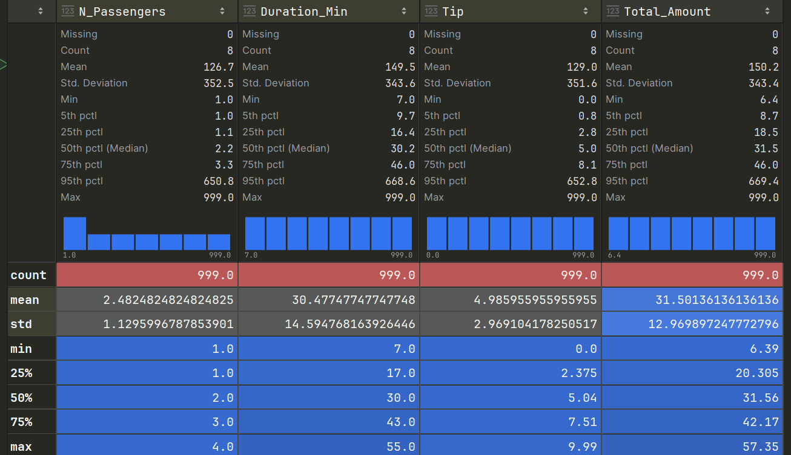**Generate summary statistics tables which consist of extreme values (min & max), standard deviation, median and quartile elements etc. You need to generate the summary statistics for all the feature columns as well.**
2. **Cab service company ABC has instructed to your team that they are looking for data insights and they have specifically asked for following A — D questions.**
3. **How much money do drivers make each night on average? What is the distribution for Male and Female? Draw the findings using necessary charts.**

1. 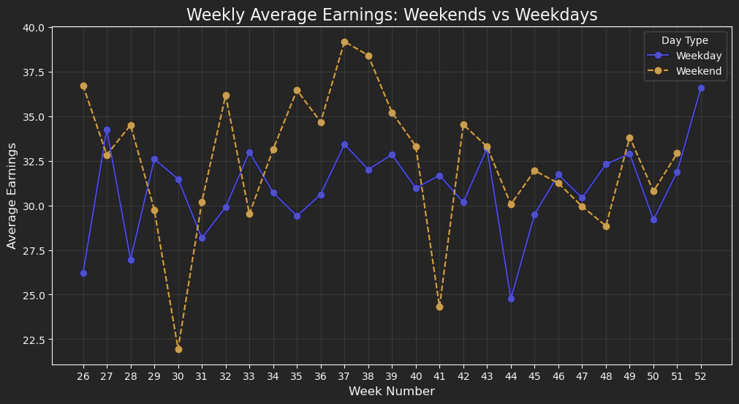**Did cab drivers from ABC make more money in weekends compared to weekdays?**

**Hypothesis Framework**

1. Null Hypothesis (H0):  
   There is no significant difference in earnings between weekends and weekdays for a given week.
2. Alternative Hypothesis (Ha):  
   There is a significant difference in earnings between weekends and weekdays for a given week.

**Results**

After performing the t-tests for all weeks, the p-values for every week except one week were found to be greater than 0.05.

Interpretation:

* Since the p-values for all weeks exceeded the significance threshold, we fail to reject the null hypothesis for all weeks.
* This indicates that there is no statistically significant difference in earnings between weekends and weekdays for any week in the dataset.

1. **Where are the best Colombo states in Colombo for drivers to be, in order to pick up profitable fares? How does this vary at different times of the day for Male and Female drivers?**
2. **How much are drivers tipped? How do tipping rates vary by Colombo state ID? Draw a colour matrix to represent the details in visually.**
3. **In addition to the above 4 key questions, describe 2 more explorative data analysis questions that you can answer. Describe those 2 key questions and show all the explorative analysis.**
4. **From above analysis describe 3 key insights that you can provide it to Company ABC**